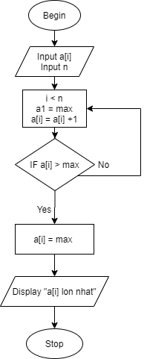

**BEGIN**

**INPUT** a[i],n

i < n, a1 = max, a[i] = a[i] +1

**IF** a[i] > max

a[i] = max

**Display** “a[i] lon nhat “

**END IF**

**END**